Window Skins Product
WindowSkinTM by WexEnergy.
WindowSkinTM by WexEnergy is a window retrofit solution available for implementation today. WindowSkins provide as much as 75% of the insulation of a new Energy Star window for less than 15% of its new window replacement cost.
The product is simple and elegant. It attaches to the windowpane in each of the four corners and traps the air against the pane. It doesn’t interfere with window operation or window treatments. It takes a minute to attach with no tools required. They’ve been installed in the real environment and are performing. WindowSkin is a significant solution that’s ready now.
I would also like to provide you with product information that can be shared with you colleagues:
1. WindowSkinTM Product brochure (digital version)
2. Video of a recent installation in Camillus, NY. Please note that this installation was in a historic building, 1915 build.
3. Video of Rob Rosen, Energy Analyst at Taitem Engineering PC (Ithaca NY) discussing the impact of WindowSkin.
Have a great day and I look forward to continuing this conversation.
Rachel
Rachel N. Rosen
President, CEO & Co-Founder
WexEnergy LLC
www.wexenergy.com
O: 585.213.5101
C: 585.259.0224
EM: rachelrosen@wexenergy.com
Smart windows wear WindowSkinTM

Attachments area

Preview YouTube video 1st Commercial WindowSkin Installation in Upstate NY

1st Commercial WindowSkin Installation in Upstate NY

Preview YouTube video Taitem Engineering talks about WindowSkin by WexEnergy

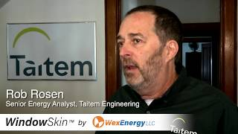
Taitem Engineering talks about WindowSkin by WexEnergy

